**PROJECT REPORT TEMPLATE**

**TITLE : Unearthing The Environmental Impact Of Human Activity: A Global CO2 Emission Analysis**

**INTRODUCTION:**

**Global warming is one of the biggest challenges currently being faced by the human race, although correlation is not causation, a likely cause of global warming is due to increased atmospheric carbon dioxide from human activities.CO2 Emission refers to the Carbon Dioxide emitted throughout the world. For this analysis we will be focusing on CO2 Emissions and its effect on the world we live in as well as some key factors and stats that may play a role in the emission of CO2 globally.**

**PROBLEM DEFINITION AND DESIGN THINKING : EMPATHY MAP:**

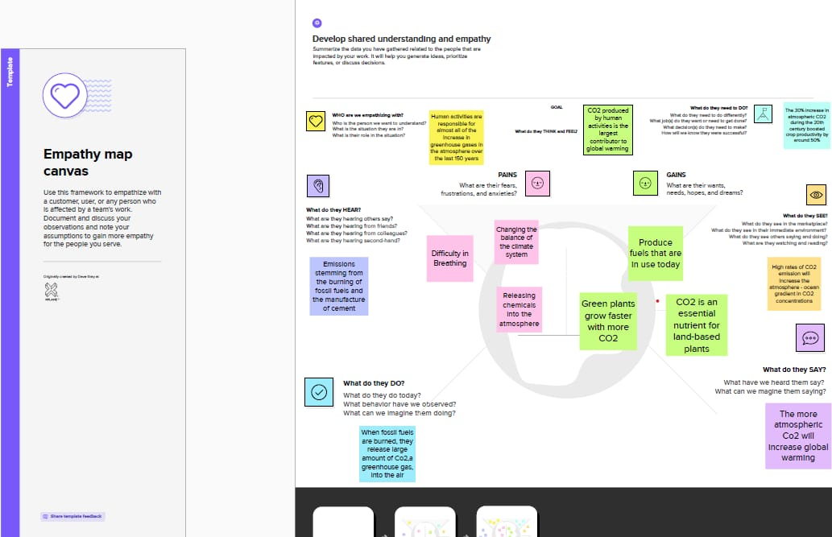

**BRAINSTORM:** 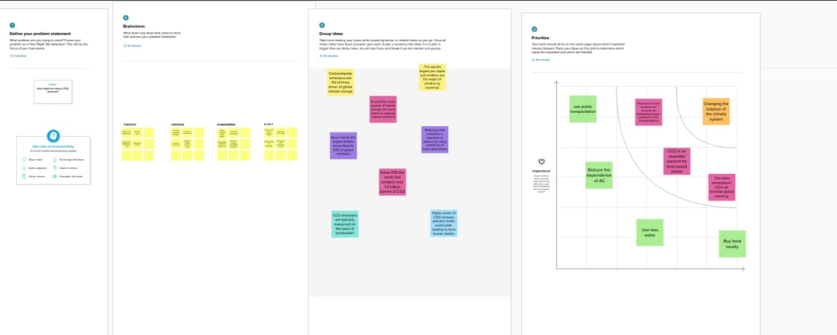

**ADVANTAGES OF CO2 EMISSION ANALYSIS:**

**Pure CO2 gas is chemically inert, transparent, colorless, and odorless. On a cold winter day, chilled air often condenses the water vapor of human breath—of which 4 to 5 percent is CO2—into visible fog. Such fog, however, is not CO2.**

**All animals, including humans, owe their existence to green plants that use energy from sunlight to convert CO2 and water molecules into carbohydrates, releasing oxygen into the atmosphere in the process.**

**Land plants get the carbon they need from CO2 in the air, and they obtain other essential nutrients from the soil. Just as plants grow better in fertilized, well-watered soils, they grow better with CO2 concentrations several times higher than the Earth’s current level.**

**CO2’s nutritional value is only part of its benefit for plants. No less important is CO2’s contribution to making plants more drought-resistant: plant leaves are perforated by stomata, surface holes that allow CO2 to diffuse from the atmosphere into the leaf’s interior, where they are photosynthesized into carbohydrates.**

**DISADVANTAGES OF CO2 EMISSION ANALYSIS:**

**GREENHOUSE EFFECT: The greenhouse effect works like a real greenhouse: Gases from the Earth’s atmosphere are trapped in the sun’s heat.Greenhouse gases essentially trap heat on the planet. The more emissions increase, the more effect this has on the atmosphere, raising temperatures on our planet.**

**IMPACT ON PLANTS: According to a study by NASA, higher levels of CO2 in the atmosphere affect crops and plants by increasing the rate of photosynthesis and reducing the amount of water loss in plants through transpiration. When carbon dioxide levels increase, the plant’s stomata, or tiny pores, don’t open as wide. This leads to faster photosynthesis and less water loss, which in theory should lead to higher water efficiency.**

**EFFECT ON HUMAN AND ANIMAL HEALTH: At the current rate, this high level of CO2 doesn’t have a direct effect on humans, but the side effects it causes on nature could be detrimental in the longer-term if major efforts are not made to slow carbon emissions down.**

**Some of the major long-term effects are:**

**Heat Waves – Already the deadliest extreme weather type, an increase in CO2 directly leads to increased Earth temperatures. The hotter it gets, the tougher it will be to survive.**

**Pollution – Pollution currently kills 9 million people per year. Higher levels of CO2 increase pollution levels worldwide, leading to more human deaths for every degree increased.**

**Insect Plagues – Warmer weather increases the arrival of mosquitos, ticks and other disease-carrying insects. These pests expand their territory and remain longer before the cold weather removes them, essentially increasing the potential victims of their diseases.**

**Hurricanes, Fires and Other Natural Disasters – As the Earth gets warmer the ice melts, causing increased water levels. This ultimately impacts our natural weather patterns, causing an increase in hurricanes and large storms. Another effect of warmer weather is an increase in forest fires burning for a longer period because the trees and vegetation are dryer and more flammable.**

**APPLICATIONS:**

**Multi-Industry Uses for Carbon Dioxide (CO2):**

**Carbon dioxide in solid and in liquid form is used for refrigeration and cooling. It is used as an inert gas in chemical processes, in the storage of carbon powder and in fire extinguishers.**

**Metal Industry:**

**Carbon dioxide is used in the manufacture of casting molds to enhance their hardness.**

**Manufacturing and Construction Uses:**

**Carbon dioxide is used on a large scale as a shield gas in MIG/MAG welding, where the gas protects the weld puddle against oxidation by the surrounding air. A mixture of argon and carbon dioxide is commonly used today to achieve a higher welding rate and reduce the need for post weld treatment.**

**Dry ice pellets are used to replace sandblasting when removing paint from surfaces. It aids in reducing the cost of disposal and cleanup.**

**Chemicals, Pharmaceuticals and Petroleum Industry Uses:**

**Large quantities are used as a raw material in the chemical process industry, especially for methanol and urea production.**

**Carbon dioxide is used in oil wells for oil extraction and to maintain pressure within a formation.. When CO2 is pumped into an oil well, it is partially dissolved into the oil, rendering it less viscous, allowing the oil to be extracted more easily from the bedrock. Considerably more oil can be extracted from through this process.**

**Rubber and Plastics Industry Uses:**

**Flash is removed from rubber objects by tumbling them with crushed dry ice in a rotating drum.**

**DASHBOARD:**

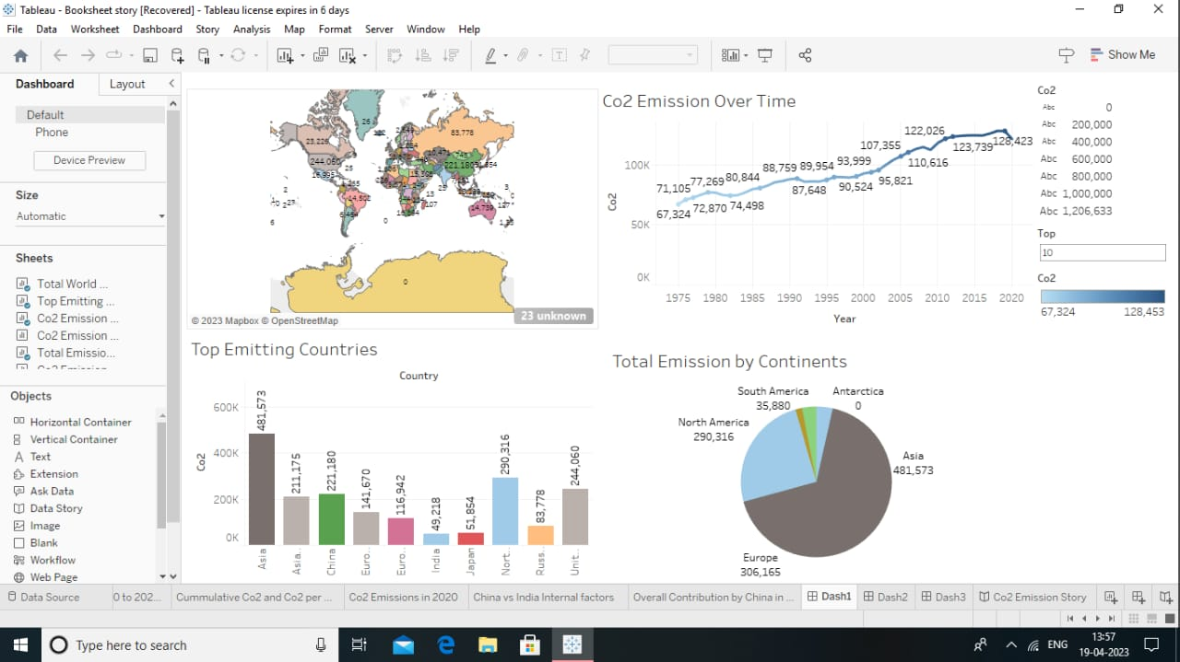

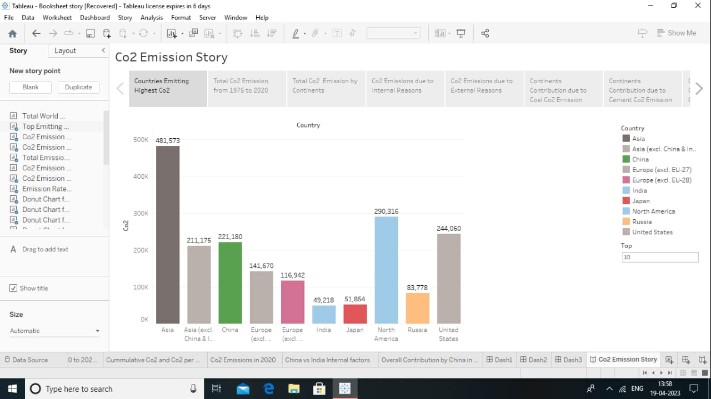**FUTURE SCOPE:**

**EIA’s International Energy Outlook 2021 (IEO2021) Reference case projects that if current policy and technology trends continue, global energy consumption and energy-related CO2 emissions will increase from 2020 through 2050 as a result of population and economic growth. However, projected future growth in energy-related CO2 emissions is not evenly distributed across the world, and the majority of the projected future growth in energy-related CO2 emissions is among the group of countries outside the Organization for Economic Cooperation and Development (OECD).**

**CONCLUSION:**

**I got an embedded map, to create a web template to finish my project. I add this picture also.**

**.**

